**A2+ LESSON 4**

**Food and Drink—Likes and Dislikes**

Are you good at cooking?

What’s your favorite food?

What’s one food that you LOVE?

What food do you NOT like?

Do you like eating vegetables?

Which do you prefer, meat or fish?

Do you enjoy eating in restaurants?

Do you eat meat?

Which do you prefer, coffee or tea?

Do you enjoy cooking?

Do you know how to make a chocolate cake?

Is chocolate cake fattening?

Do you like sweet foods?

Do you like Chinese food?

Do you drink a cup of coffee in the morning?

Do you ever drink coffee black?

How often do you eat in restaurants?

Are apples a kind of fruit?

Which do you prefer, vegetables or fruit?

Are vegetables good for your health?

Is chocolate cake good for your health?

What do they like to eat?

What foods do they dislike?

Can they cook?

How often do they eat in restaurants?

A2+ Vocabulary 1

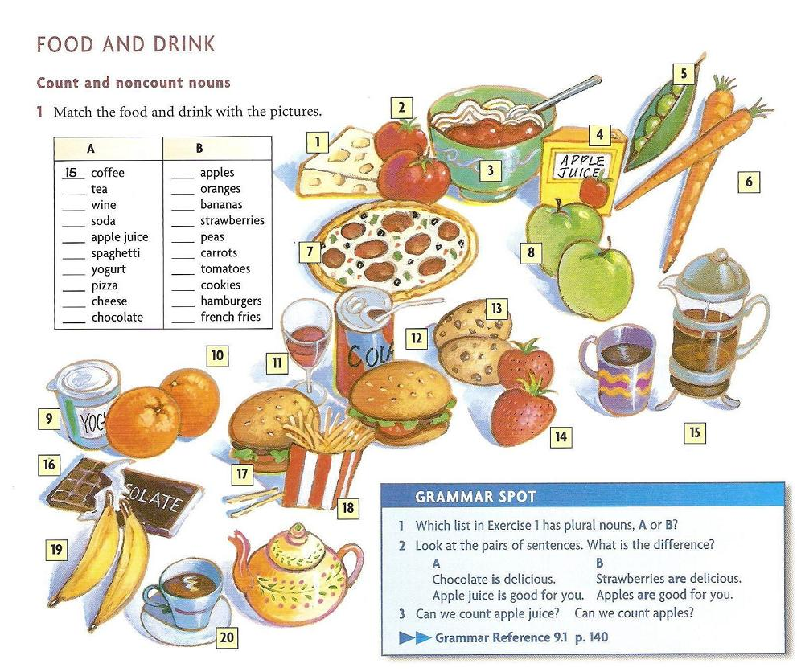

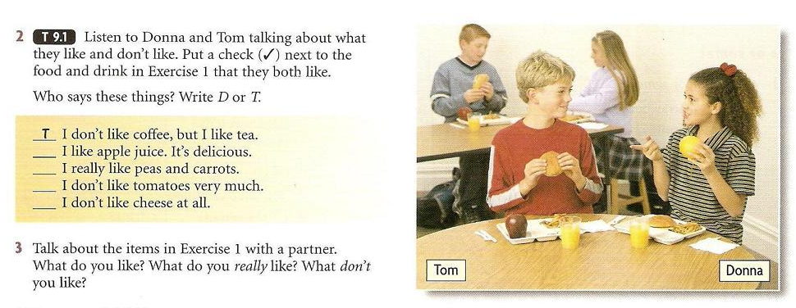

**MODAL VERB: WOULD**

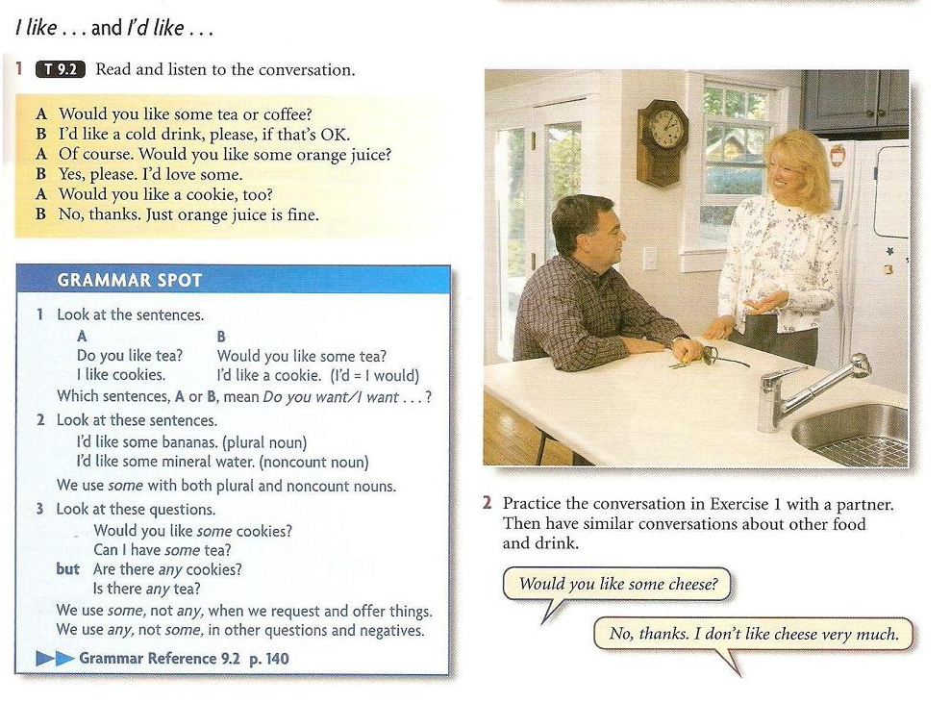

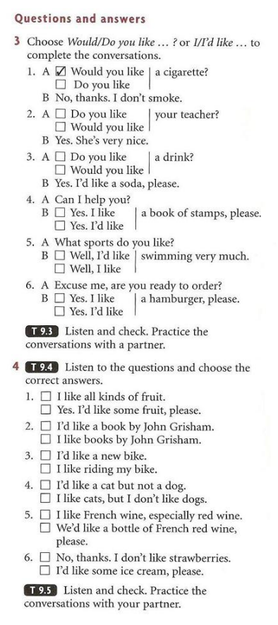

**These pictures show different kinds of food.**

What kind of food is in picture 1? [meat] What kinds of meat do you see? chicken, sausage, pork beef, lamb, turkey, ham...

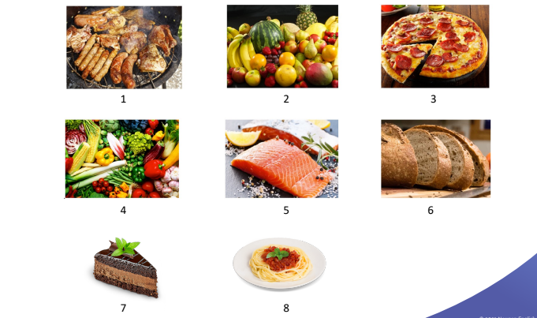

**Possible answers:**

1. meat: chicken, sausage, pork

2. fruit: watermelon, bananas, mango, strawberries, pears, apples, grapes, melon

3. a pizza / a piece of pizza

4. vegetables: cabbage, corn, Brussel sprouts, garlic, tomatoes, leeks / onions, chili peppers, eggplant, broccoli, beans, peas, artichoke

5. fish: salmon

6. bread: whole wheat bread, a loaf of bread

7. dessert: a piece of chocolate cake

8. pasta / spaghetti: a plate of spaghetti with tomato sauce

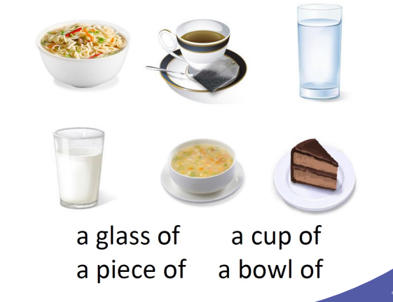

[a glass of] [a cup of] [a piece of] [a bowl of]

What food can you use “a cup of?” for? [coffee, tea, soup]

What food can be a glass of? [milk, water, juice]

What food can be a bowl of? [soup, noodles, ice cream]

What food can be a piece of? [cake, fish, pie]

**Main Activity 2: National Cuisines**

Look at these pictures of people eating. They are from different cultures and countries. They are eating their food differently.

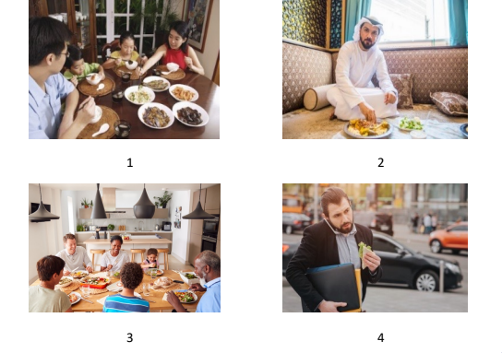

1. The family is probably from Asia. They are using chopsticks and spoons. They are sharing food. Their food is in bowls

2. The man is sitting on the floor. He is eating with his hand. He is probably from the Middle East.

3. This is a large family. They are eating in the dining room. They are eating vegetables. They are eating a salad. They are drinking water. They may be from Europe or North America.

4. The man is walking, eating, and talking on his phone at the same time. He is eating a sandwich. He is probably a

businessperson. He may be from Europe or North America.

What does the word **“cuisine”** mean? [A cuisine is a style of food or cooking often connected to a country or region.] Good. What is an example of a cuisine? “Chinese cuisine” or “French cuisine.”

What is your favorite cuisine? [My favorite cuisine is _____.] Why is it your favorite? [Because _____.]

